**Employee Turn-over Predictions**

1)To display the KPIs ,measure the average of the Work-Life balance,the average of the Job Involvement range,the average of office Relationship satisfaction and the sum of overtime working employees in each role and department.

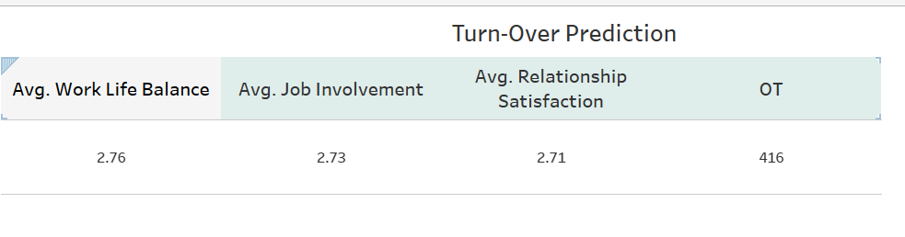

2) Work-Life Balance and Relationship Rating

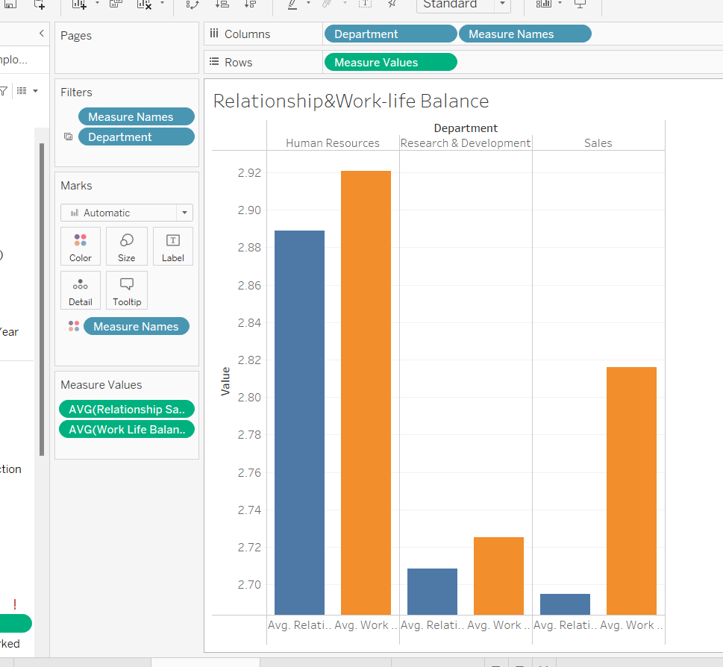

3)Job Involvement

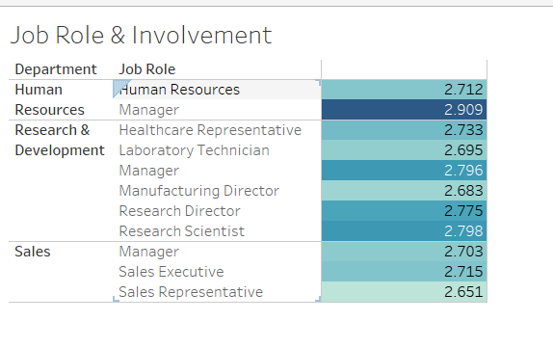4)Overtime Distribution

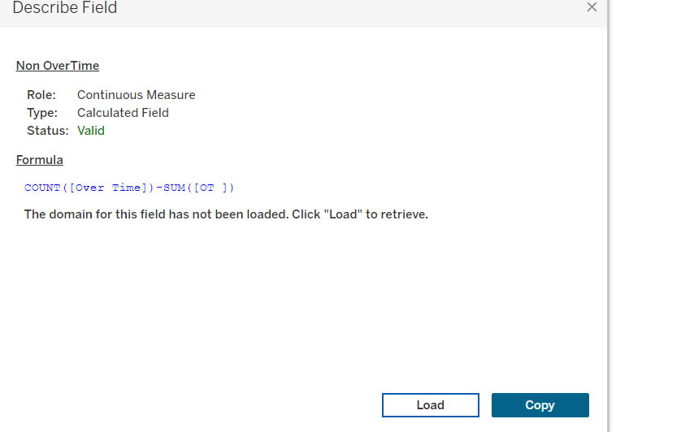

**Analysis and Findings**

**1.Work-Life Balance**

It is evident that work life balance is lower in the Research & Development Department lies at an average of 2.72 and 2.68 for Manufacturing Director role in particular.

**2. Job Involvement**

It is evident that Job involvement is lower in Sales department lies at an average of 2.65 for Sales Representative role.

**3. Relationship Satisfaction**

It is evident that office relationship is lower in Sales department lies at an average of 2.69

**4.OverTime Distribution**

It is evident that overtime distribution is larger in terms of Research & Development department .

**Areas of Improvement**

To promote employee engagement and work-life balance the concern can

* Prioritize Feedback of Sales department employees.

*Prioritize R&D employees’ physical and mental health as they are working overtime.

*Recognize Top Performers and Achievers in the Sales Department as the job involvement is much lower when compared with other departments.

*Plan for Team outings often for Sales Department as the relationship is weaker in the case of Sales department.

*Offer Professional Development Opportunities to the employees in the Sales Department.

**Practical Solutions**

Steps to take to have a good employee engagement in the company are:

* Sponsor workout classes as company outings and consider offering fitness subsidies to encourage healthy lifestyles beyond the office. Offer meditation classes and encourage employees to take mental health days when they need to step away from the office and focus on themselves.

*Look for a volunteer opportunity that’s located near the office and plan an event for after work. This is an easy way to create [team building activities](https://builtin.com/people-management/virtual-team-building) and give back to the community. Additionally, offer a “Volunteer Day” as an [employee benefit](https://builtin.com/recruiting/employee-benefits).

*Giving each individual the opportunity to voice their opinions encourages honest, open communication. Employee feedback is essential to successfully engaging the workforce.

*By providing new employees with [effective onboarding](https://builtin.com/recruiting/employee-onboarding), you let them know they have a place in your company and its culture. Take the time to explain the nuances of the team, the goals and values of the company as well as their position’s purpose. This not only sets them up for success in the role but also conveys their value to the organization’s mission.

*Outlining a path for growth and offering Professional Development opportunities will create engaged employees and help retain top talent. Not only that, but contributing financially or otherwise to your employees’ individual growth shows that you value them, in addition to their work.

*Last but not least, stock the kitchen with healthy snacks that will fuel employees during the busy work day.